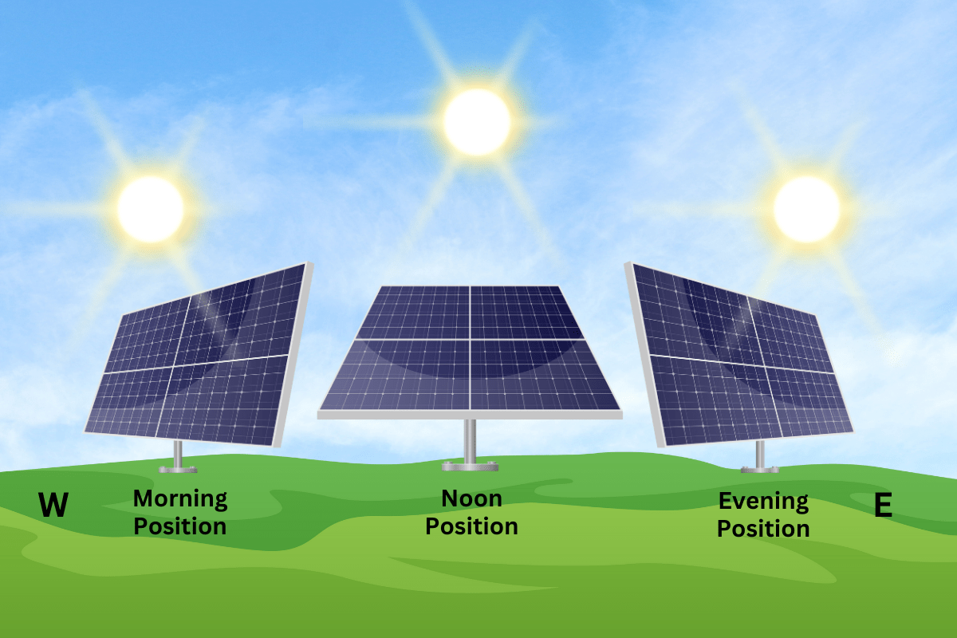
Smart Solar Tracker:
Dual-Mode Precision with MATLAB Response Analysis for Harnessing the Sun Efficiently

In a world moving toward clean energy, making the most of every ray of sunlight is essential. This project introduces a dual-mode smart solar tracking system that ensures solar panels always face the sun for maximum efficiency.

At its core, the system uses light sensors (LDRs) to detect sunlight and a PID controller to smoothly adjust the panel’s position with a servo motor. Unlike fixed panels that miss out on peak sunlight, this tracker continuously aligns itself, minimizing wasted energy.

- What makes it special is its versatility:
In automatic mode, the PID controller guarantees stability, reducing oscillations and keeping the panel perfectly aligned.
In manual mode, users can easily control the panel with a simple remote.
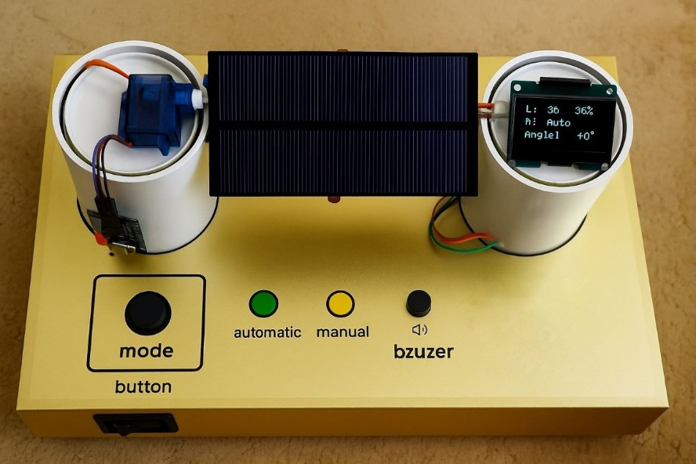

To make the system user-friendly, it features LED indicators, a buzzer, and an OLED display that shows real-time data. Performance was also analyzed in MATLAB, revealing how the PID-controlled version delivers smoother, faster, and more accurate tracking compared to a non-PID design.

By combining control theory, embedded systems, and renewable energy concepts, this project demonstrates how affordable technology can create smart, energy-efficient solutions with real impact for the future.

